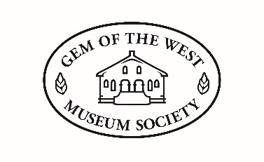

2023 Summer Employment Job Description

Job title: Museum Assistant
Job Type: Temporary/Student
Duration: May 16th – September 2nd
Hours: 30 hours per week
Wage: $17/hour
Duties:
- Scheduled work days are Tuesday to Saturday during hours of operation.
- Supervise the museum day to day tasks, including opening and closing the facility, operating reception, cash management, and providing information on museum exhibits to visitors and tourist information.
- Assist with the publication of digital content for social media.
- Work with the Society Manager and the Collection Management Committee to undertake a project assessing and recording previously uncatalogued artifacts within the museum collection.
- Assist in artifact cataloguing, research, creating artifact labels, and organizational tasks
- Assist with other duties and functions as required
The ideal candidate will:
- Excel at public speaking and engaging with members of the public
- Possess strong verbal and interpersonal skills
- Be efficient and well organized
- Be able to work well independently with minimal supervision
- Knowledge of digital media
- Know of or be able to learn Microsoft Office programs, word press and past perfect software.
Applicants must meet the eligibility requirements of the Canada Summer Jobs.

